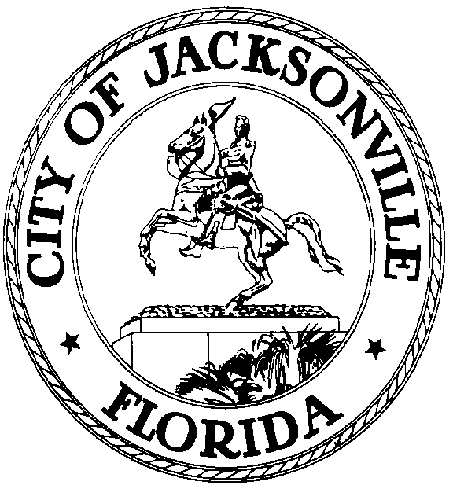

GARRETT L. DENNIS
Council Member District 9
E-Mail: GarrettD@coj.net

OFFICE OF THE CITY COUNCIL
117 West Duval Street City Hall, Suite 425
Jacksonville, Florida 32202
Office (904) 255-5209
Fax (904) 255-5230
.

MEDIA RELEASE

FOR IMMEDIATE RELEASE – October 9, 2020
Contact: Garrett Dennis (904) 887-1870

COUNCILMAN GARRETT DENNIS INTRODUCES LEGISLATION TO CREATE CANNABIS CIVIL CITATION PROGRAM

JACKSONVILLE, Fla. – Councilman Garrett Dennis has filed a bill that would create a civil citation program as an alternative to making arrests for possession of twenty grams or less of cannabis. The civil citation program would provide police officers the option to issue a civil citation or require the completion of community service hours.

“Last year, I advanced civil citation legislation which did not receive the support required from my colleagues to become law. Under the leadership of Council President Hazouri, the City Council has a heightened focus on social justice. After another year of continuing to observe other municipalities take similar action, it’s time we revisit this very critical issue in Jacksonville. I look forward to robust public discussion with my colleagues and community input,” Dennis said.

